Project Title

A major project report submitted in partial fulfillment of the requirement for the award of degree of

Bachelor of Technology
in
Computer Science & Engineering

Submitted by
Student Name (Roll No.)

Under the guidance & supervision of
Supervisor Name
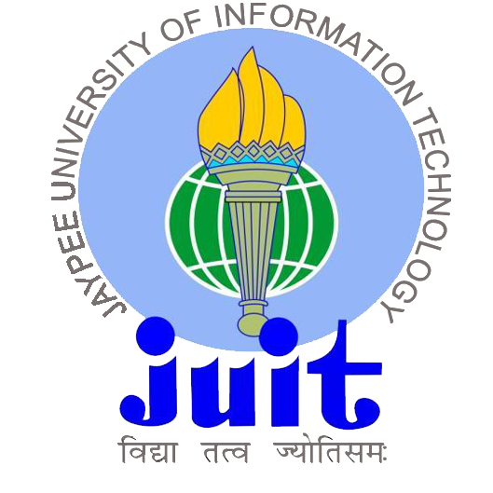

Department of Computer Science & Engineering and
Information Technology
Jaypee University of Information Technology, Waknaghat, Solan - 173234 (India)

December 2025

